Style Guide

Aesthetic

Swamp/Ruins/Great Tree:

* I want the swamp to have a distinctly slimy feel, but with an air of life around it.
* From what I’ve seen Swamps are a humid environment full to the brim with small lifeforms ranging from microbes to frogs and snakes but have the occasional large predator such as gators.
* However, they also have some of the largest lifeforms in the world. Mammoth sized trees that can crowd out and choke all other forms of life because of the plentiful nutrition that abounds in swamps.
* The swamp in the game is a series of platforms, willow like trees, and a ruined village that I want to look as if it has been reclaimed by the environment.
* The platforms will have an eroded feel to the base but vibrant patchy growth on top as if the bottom is loose and being eaten by the swamp but the top is growing fine.
* If I can manage it, I would like to have a mist layer under the platforms but over the water that will be the base layer of the whole swamp environment.

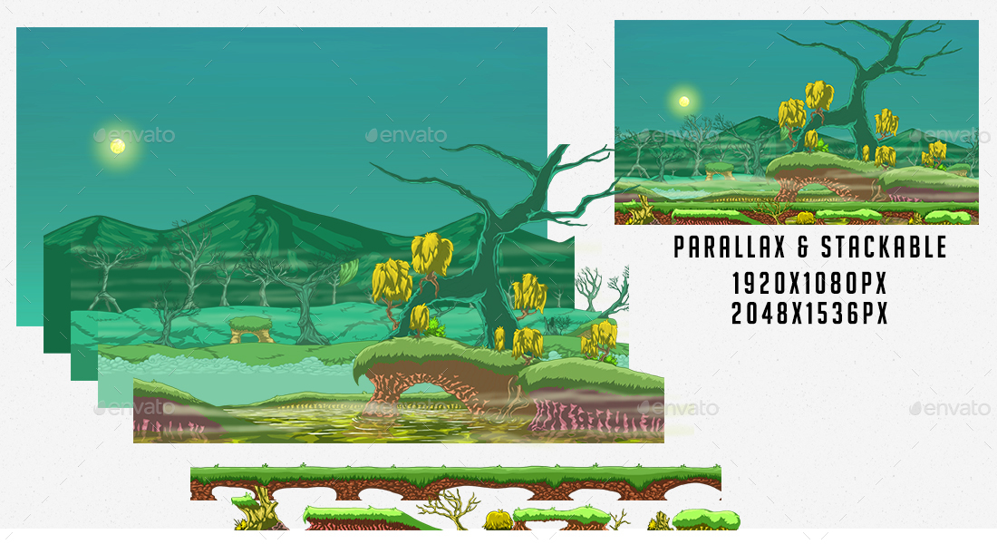

* The Trees will be gnarled trunks with low hanging willow strand branches. One is growing out of the side of a short cliff and the player will climb up between its roots.
* The ruins will be stone buildings with faded red cobbled roofs. They will have vines covering them and the first signs of the root system for the Great Tree.
* Right now I only have 4 or 5 buildings in my ruins

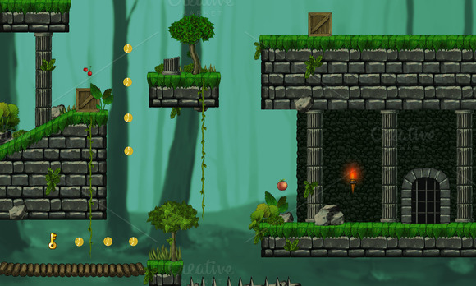

* The Great Tree will be a vast network of roots leading up to the main trunk, a hollow trunk with visual cutouts that allow the player enough of a view to jump up through it, and a canopy of branches leading up to the top foliage of the tree and back down again.
* The pick-up of Great Tree will be Honey and a secret pick up yet to be determined.
* Color Palette: Greens and Browns, dark earth and slimy water

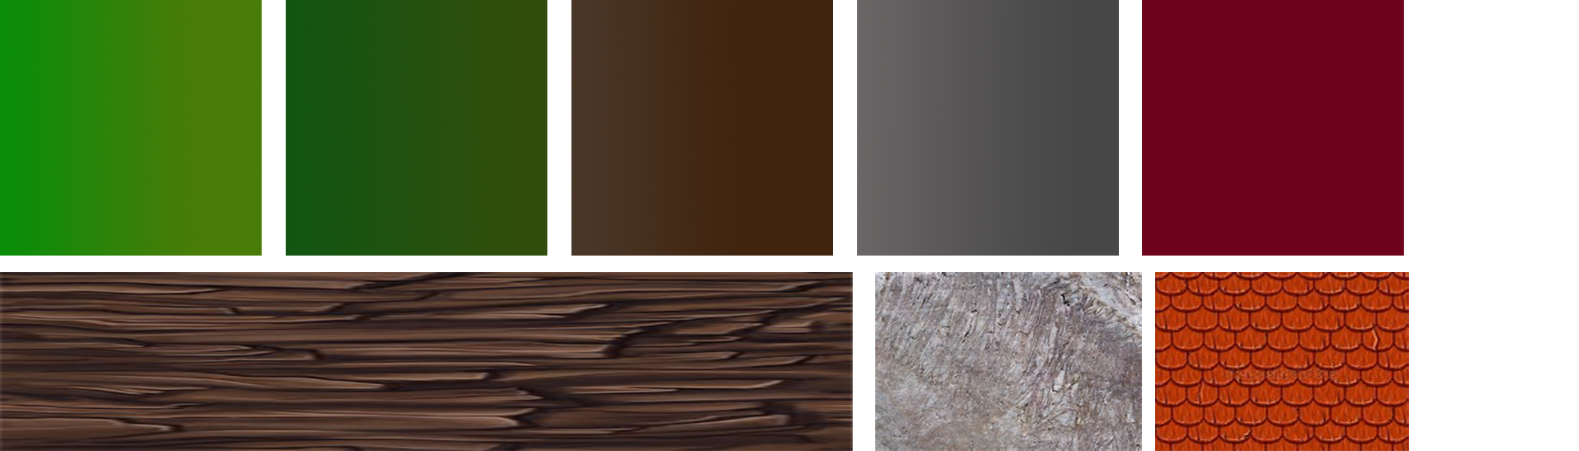

Temple:

* The feel of the temple that I want to Try for is “Mystical”.
* There’s are going to be clean white stone, Vibrant carpets. Bright lights, Glowing Pathways for the moving platforms, and golden idols.
* The feel will be distinctly less organic than the swamp and great tree.
* There will be harsh geometry’s all over with the afore mentioned carpets being the only thing to smooth out certain areas.
* The main goal of the temple is to continue to move upwards through the level but the end goal is left vague so the awe inspiring final Idle will wow the player and the dramatic transition between Temple and Forest zone via “Ancient teleporter: will be exciting.
* There will be graphics and visual clues to support the upward progression of the zone. I plan on making statues that will show the way.
* Color Palette: Clean white stone, blue, red carpet, Gold, vibrant colors for keys.

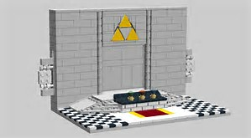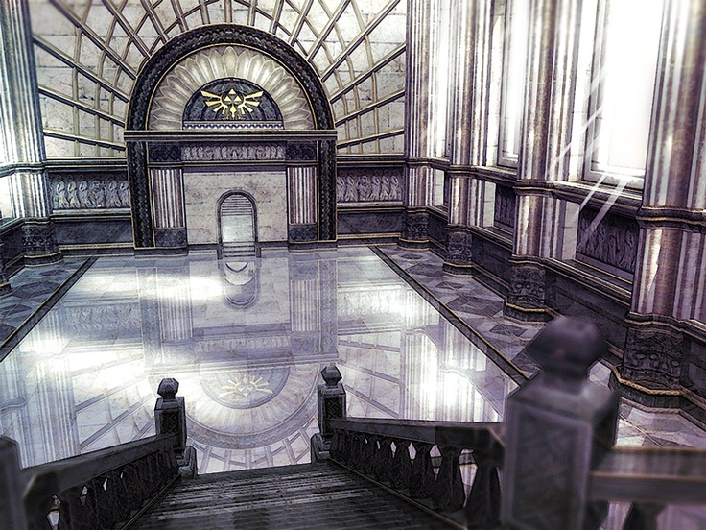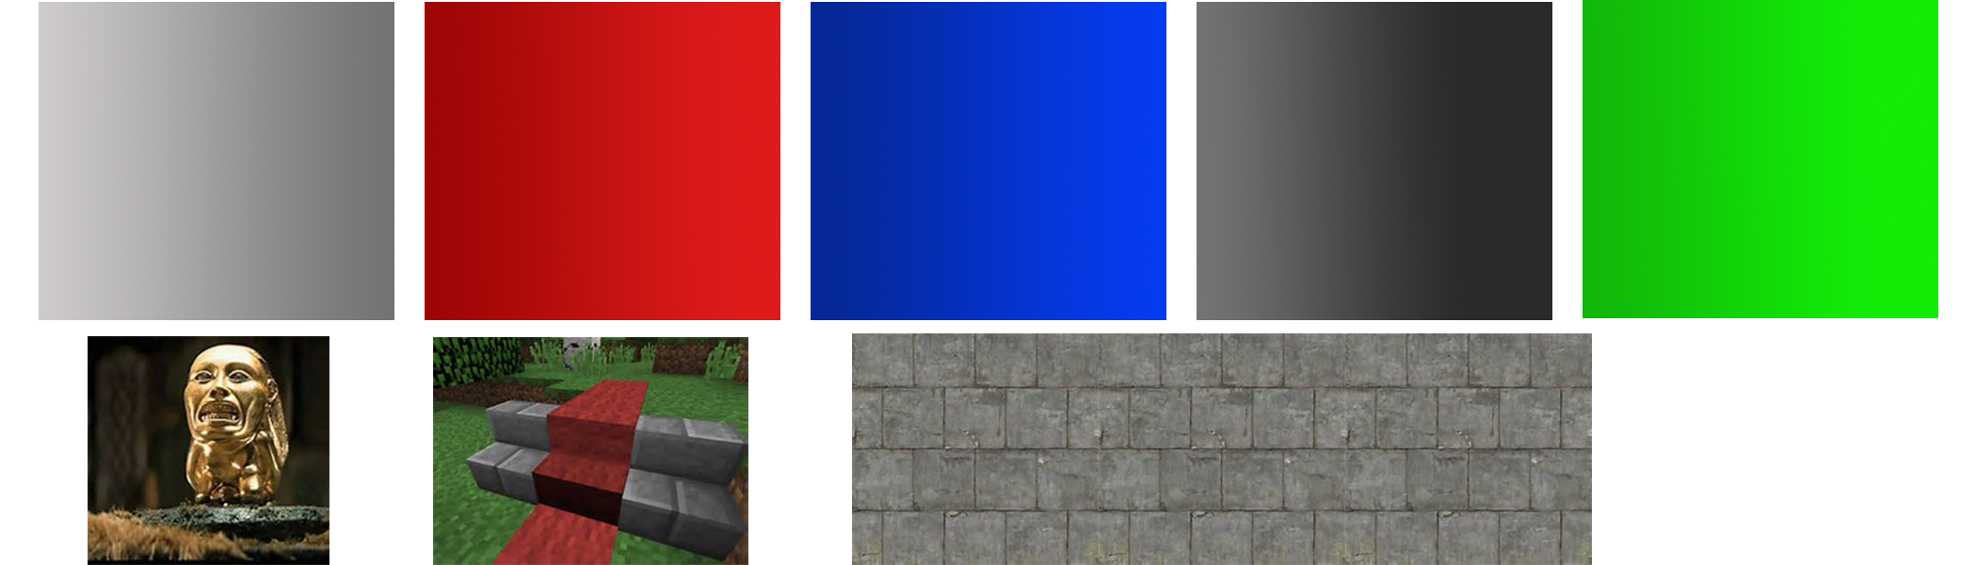

Cave/Mountain

* My Cave zone is the last Area on the level of the Game.
* It starts with a long but quick paces climb up the mountain the cave is “in”
* The platforms used to climb up the mountain fall out from underneath the player.
* I want to make the Unstable Platforms look as though they are literally one step from falling from the sky. This means a crumpling texture and narrowing base.
* The stable platforms will be a darker color and have a better stronger looking base.

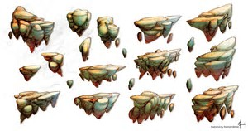

* The peak of the mountain will be snow capped with only a low hanging ledge marking the way under.
* Inside the mountain will be dark and I would like there to be a slow transition encroaching darkness as you go further in.
* The color palette will shade further into darker colors.
* There will be ambient light sources as you go further down that will light the way forward. These will include a glowing underground river and glowing geodes.

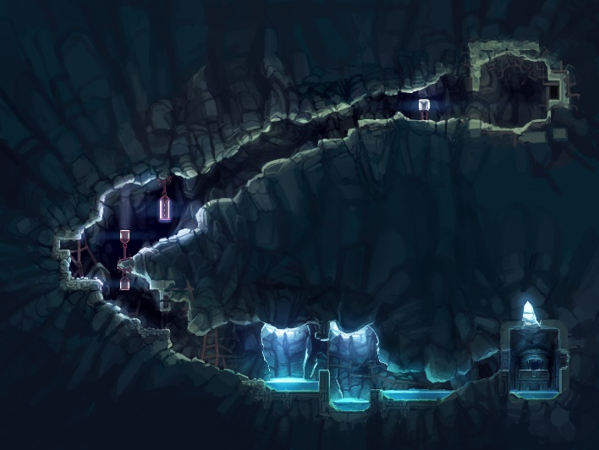

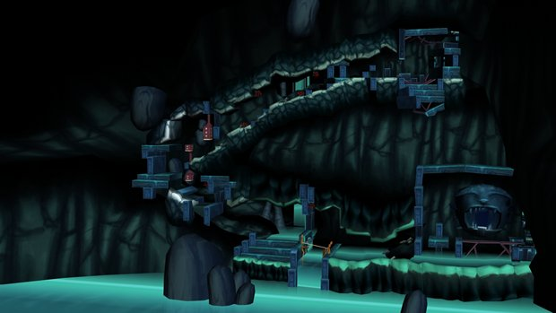

* Color Palette: Stone Greys and Tans, Dark Browns and purples with brighter colors for the geodes and river.

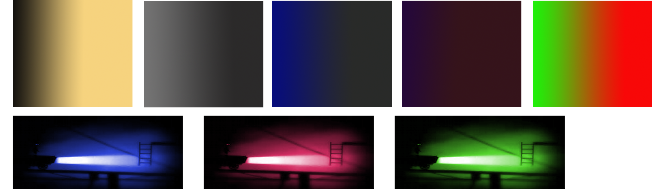

Elements 2D/3D:

* I plan on using a simple mix of 2D backgrounds and 3D playable areas. I know I need to improve the quality of my foreground are and will do so with 3D objects.
* I plan on having Sky and background paintings for most of my areas expect for when the player is scaling the mountain. Then I want to give way to an epic 3D water fall.

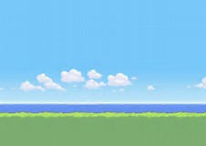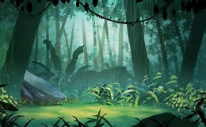

Sound/FX

* For sound I will find specific ambiance for each zone
  + Swamp: Bird calls, gloopy noises like in a bog or tar pit, hissing snakes, frog ribbits, maybe even low unspecific moaning. Ambiance will stop when approaching an enemy (snake). No music
  + Temple: maybe some Gregorian chants, some light glowing noises animating from walls and idols, swishing noises for the moving platform, stone grinding for the third flow squishing platform.
  + Cave: No music, Drips, rumbling earth noises, Waterfall noises on the scale up, crumbling stone noises on the falling platforms, rushing of the underwater river. Bat calls.
* The main character will have a range of noises: footsteps (classic tup tup tup), an exclamation for jumping and a grunt for falling.